FOR IMMEDIATE RELEASE

Show-Stopper Bolt B80: SP/Silicon Power Launches Its First Portable SSD

Taipei, Taiwan – October 11, 2017 –SP/ Silicon Power releases its first portable SSD, the Bolt B80, which combines bold design, impressive performance and safe storage.
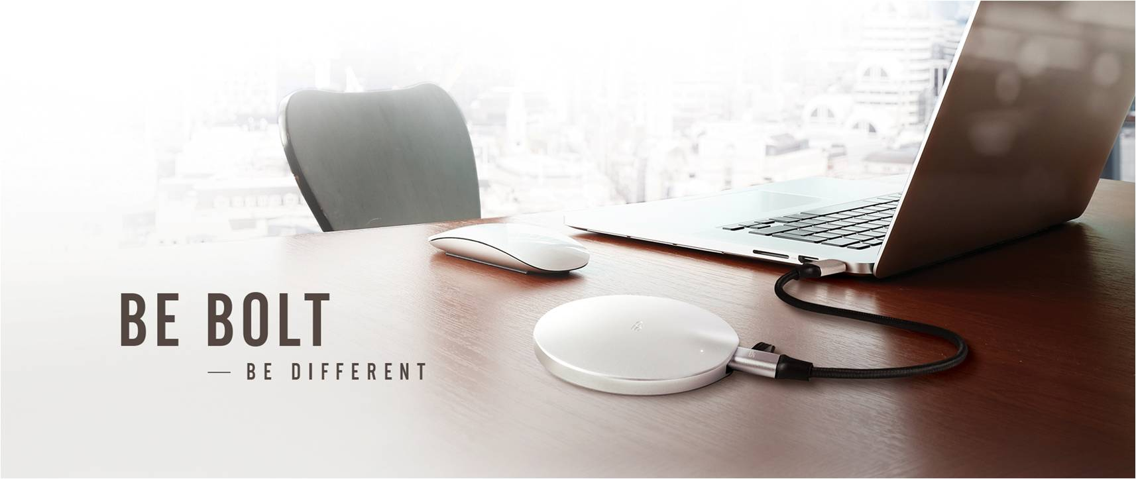
Design
The Bolt B80 impresses with an extraordinary design, shape, size, as well as feather lightness. Its futuristically stylish UFO-shaped aluminum housing measures only 1.2cm thick and 7.5cm in diameter and will glide effortlessly into pockets or bags for safe storage.

Performance
Equipped with a Type-C port and USB 3.1 Gen 2 interface, the B80 reaches read/write speeds of up to 500/450MB/s for blistering-fast data transfers and back-ups.

Protection
The B80 has repeatedly passed a 1.22m military free fall test (MIL-STD-810G 516.7 Procedure IV) and is IP68 water and dustproof, effectively preventing data loss or damage caused by accidental drops, bumps, spills, splashes, or dust. With this level of protection, it’s the thinnest portable SSD on the market.

The Bolt B80 is made for professionals who need fast and safe local storage and trendsetters who have a weak spot for award-winning design that compliments high-end laptops and ultrabooks.

Media Contact: Nicole van Rooij
Tel.: +31 85 5600010
E-mail: nicole.vanrooij@eu.silicon-power.com

For more information, please visit the Silicon Power official website: www.silicon-power.com.

###
About SP / Silicon Power
Founded in 2003 by a group of enthusiastic data storage industry experts, Silicon Power is committed to delivering outstanding product and service quality. Headquartered and with its own state-of-the-art production site in Taipei, SP has become a leading manufacturer of flash memory cards, USB flash drives, portable hard drives, solid state drives, DRAM modules and industrial-grade products. Successfully blending innovative technology with award-winning design, the international player with four branch offices around the globe continuously strives for perfection in preserving and protecting your valuable data. Because memory is personal.

