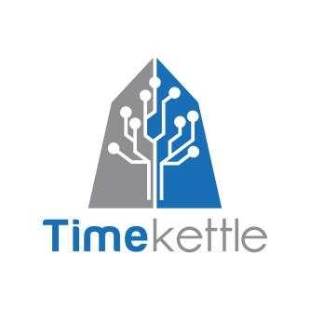
Timekettle Technologies - Artificial Intelligence
Introduction to Next Era of AI Translator at DISTREE EMA
Machine Translation, Neural Network Algorithm,
Multi-Channel Communication Technology

Founded in 2016, Timekettle Technologies is committed to building a global brand of AI translator by integrating industry-leading technology and innovative design through the combination of artificial intelligence algorithm and hardware technology.

WT2 Plus is the world’s first AI-powered translation system implementing “1+2” interaction mode (1 App controls 2 Earphones), WT2 Plus stands for Wearable Translator for 2 people, Plus indicates an upgrade from original WT2, as Timekettle has been developing this AI translator for nearly 2 years.

By integrating advanced voice algorithm and machine translation technology, WT2 Plus delivers hands-free and natural cross-language communication, regardless of language barriers. It is the first AI translator that enables users to talk freely in different languages, while keeping interaction necessity like eye contact and body language.

The creation of WT2 Plus Wearable Translator opens an new chapter in AI translator to everyday consumers. This accomplishment has been recognized by numbers of international awards including iF, Good Design, and Innovation Award. Over the past year, Timekettle received reports from top-tier media, as well as encouraging feedback from users around the globe.

At Timekettle, we believe “Communication is connection.”

References:
WT2 Plus Official Commercial
WT2 Plus TechCrunch Shenzhen
WT2 Plus Asia-World EXPO Highlights

