Press Release

For Immediate Release

Armor-X IP68 waterproof shockproof cases for iPhone 6 and 6 Plus

With integrated X-mount system
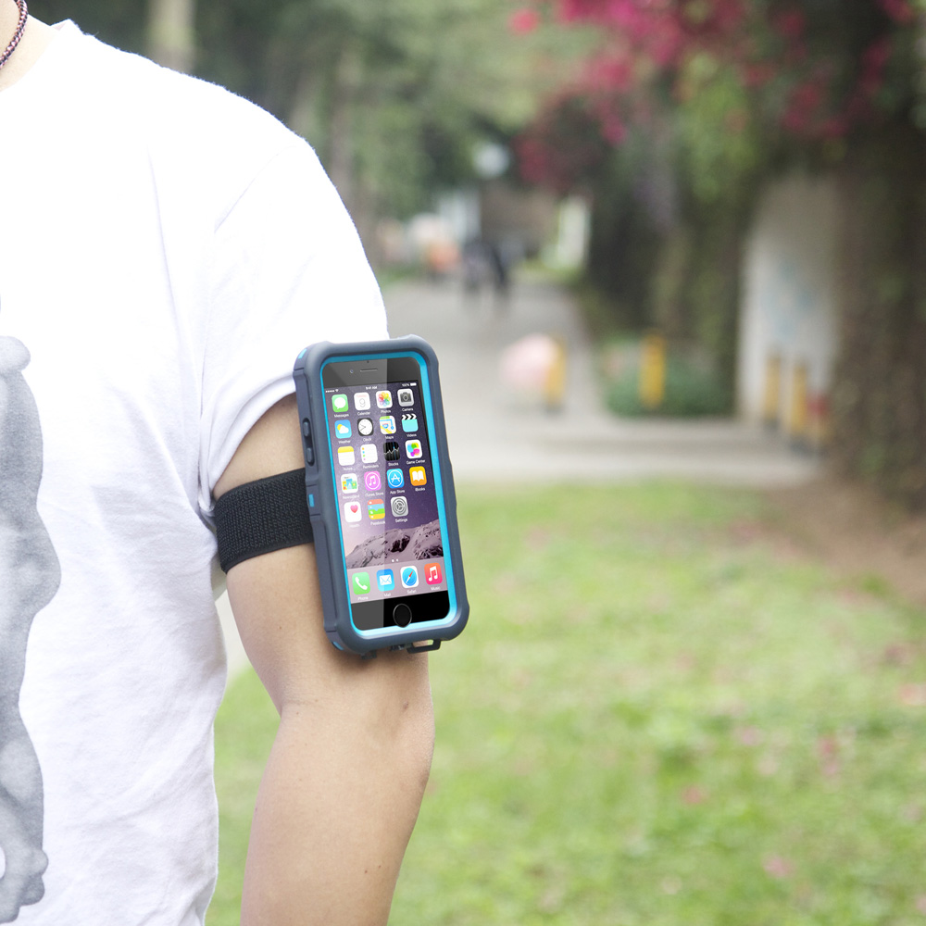
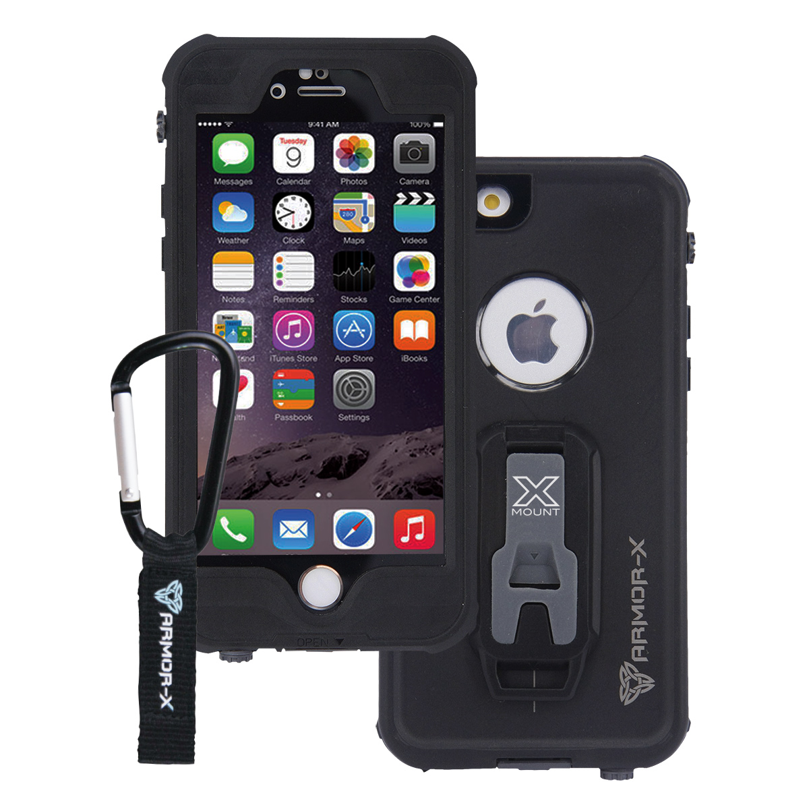

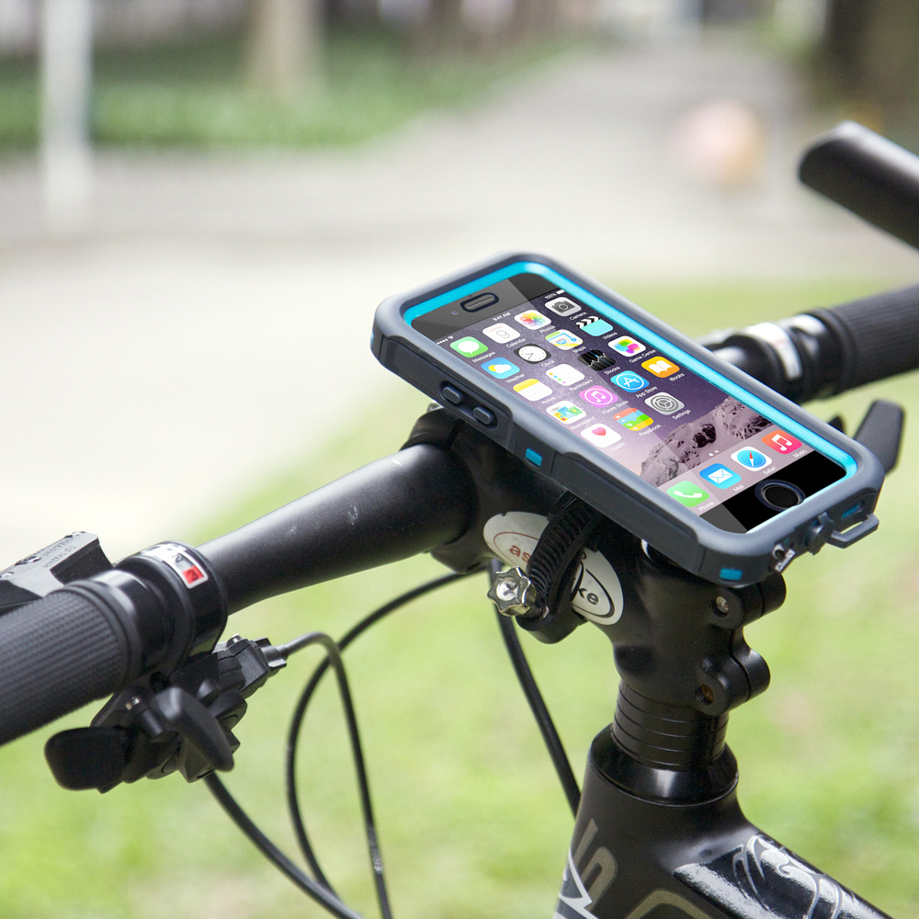

Feb, 2016.
The all-new Armor-X IP68 Waterproof Shockproof Case for iPhone 6 and 6 Plus are design for marine and water sports. X-Mount ready and constructed with dual-layers shock-absorbing TPU and protective Polycarbonate. Our IP68 waterproof case designed for your adventures even you are in extreme environments, which is able to fully submerged in water up to 2 meters for 30 minutes.

The Armor-X Waterproof Case is compatible with patented X-Mount System, which allows devices to interchangeably mount in various settings. When paired together, the use of Armor-X cases with the X-Mount system creates an ecosystem that provides users with unparalleled versatility. Smartphone and tablets are transformed into a rugged GPS navigators, Action Cameras, and companions in extreme terrains and weather.

Find out more about the Armor-X Waterproof Case with X-mount system:

About Armor-X www.armor-x.com
Armor-X is a lifestyle design collective dedicated to creating products that fuse form, function, and style. ARMOR-X was created to provide explorers of the world the highest standard of smartphone and tablet protection and mountings. Inspired with the goal of making “Armor” for personal devices, Armor-X’s extensive line of waterproof and shockproof mobile and tablet accessories allow users to bring their devices anywhere and everywhere.

- End -

For media enquiries or additional images, please contact:

James Ng
Marketing and Sales Manager | Armor-X | www.armor-x.com
E-mail: james@armor-x.com | Skype: allblacks_ng

