Wunder360 is 2100% funded and has extended the campaign for another month

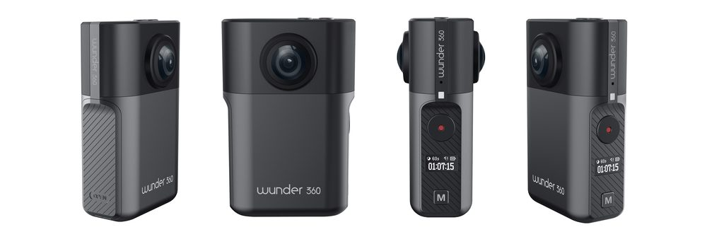

The industry leading AI camera Wunder360 S1, with real-time 360 video stitching and 3D real-world reconstruction, has extended the Indiegogo crowdsourcing campaign for another month.

After successfully funded in 30 minutes on 3rd July, the Wunder360 S1 is now more than 2100% funded with 4000+ backers. The Wunder360 team just unlocked the forth stretch goal with the funding number reached $400,000 in less than a month.

As mentioned in the beginning, Wunder360 S1 is an industry leading AI camera with the ability to stitch 360-degree photos and videos in real-time. The ability makes it immediately differentiate from the others compact 360 cameras under $500 price tag, users can directly output, stream or share the 360-degree videos from the camera without the need to wait for power-consuming after-process on their phones or PCs. For comparison, the $370 priced Ricoh Theta and the $699.99 priced GoPro Fusion both needed companion application or even more than one microSD cards for video stitching.

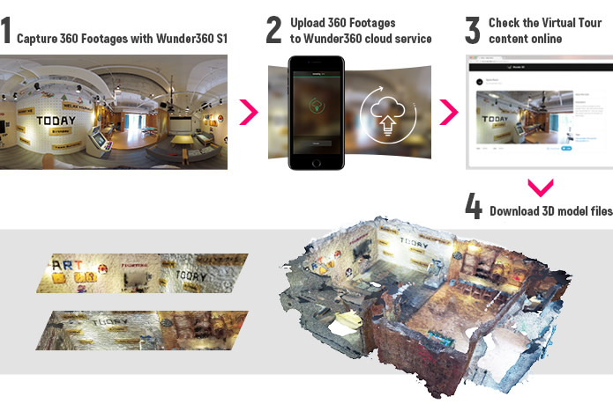

As the AI capability kept in mind during the product design process, Wunder360 S1 is also the only consumer oriented compact camera brings consumers the ability to create 3D models from their 360 footages captured by the camera. The 3D models generated by the Wunder360 cloud service is available for online sharing and to be imported into mainstream 3D editing professional software. According to the product team, the cloud service generates high enough quality 3D point cloud and create a 3D model from it. The models could also be imported into Minecraft or viewed in VR/AR headsets like HoloLens. For enthusiasts and professionals in certain areas, Wunder360 team created a tool for them to convert the models into virtual tours which could be viewed through web and mobile phones.

Benefit from the built-in high-performance DSPs and Deep Learning algorithms, the Wunder360 S1 delivers a bunch of intelligent editing functions for flat video lovers alongside the 360-degree and 3D features.

AI Smart Tracking

The computer science team of Wunder360 built a CNN (convolutional neural network) deep learning framework simulating human habits and recognizing the main subjects in the videos, which keeps the important subject in the center of the frame in auto edited videos.

Intelligent EIS

By applying the smart algorithm into the companion application, the Wunder360 team provides cinematic level EIS (Electronic Image Stabilization) to create stabilized and smooth videos from original footages.

Smart auto editing

Another advantage coming through the content recognizing deep learning framework is the ability to automatically edit a shortcut from the original video. The algorithm recognizes the POIs (point of interest) and potentially important parts of the original video and automatically creates a short video for users.

Phantom Clipper

You may have heard about multi-exposure in photographic, but it was a very sophisticated procedure for general users to create a multi-exposure like video in action. With the smart algorithm exclusively developed for Wunder360 S1, the Phantom Clipper feature captures the movements of the main subjects and automatically create multiplies of the subject in the video.

Even if you put the AI and 360-degree features aside, Wunder360 S1 is still a very competitive action camera at a $135 price tag for up to 4k resolution photos and 3k 30fps/1080p 60fps videos capturing ability. Not to mention the custom designed waterproof case that comes with the device for free providing IP60 100ft waterproof protection.

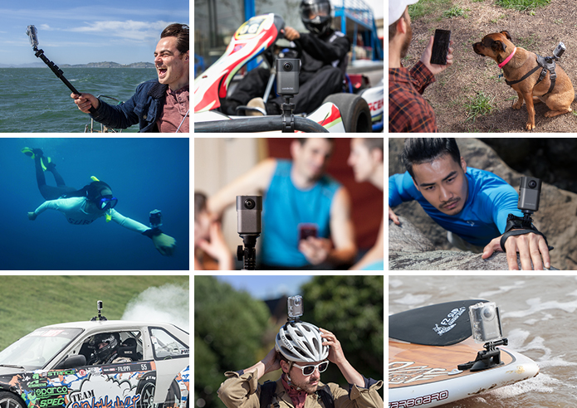

Considering the portability, Wunder360 S1 weights less than 100g (97g, to be precise) with the battery and fits right in your palm. You can buy standard action camera batteries in both online and local stores for it and the standard 1/4-inch socket on both the camera and waterproof case makes sure that you can always use Wunder360 S1 comfortably with the accessories you are familiar with.

And there is one more thing you will not want to miss, that you can directly view the 360-degree video stream from the Wunder360 S1 camera, thanks to the real-time stitching ability. It makes Wunder360 S1 an almost perfect monitoring tool for both indoor and outdoor scenarios. You will not miss a single detail with the wide angle dual-fisheye-lens.

As the campaign extended for another month, it is truly a great opportunity to grab this rich-featured compact AI camera at an early-bird price. Visit the campaign page at: https://www.indiegogo.com/projects/wunder360-s1-first-3d-scanning-360-ai-camera-vr-adventure#/

