The Newest Member of Android One Family: General Mobile “GM 5 Plus”
Always providing its users to the latest technologies, General Mobile introduced the new member of Android One program, “GM 5 Plus” in an event held during the Mobile World Congress in Barcelona, Spain.
Following the major sales figures and positive feedbacks about General Mobile Android One 4G acquired in such a short time, which was launched as a first Android One product in European market, General Mobile aims to increase the performance level with “GM 5 Plus”.
General Mobile “GM 5 Plus” provides consumers a combination of excellent hardware and the latest software to ensure the best user experience. “GM 5 Plus” users, while taking great Selfies with 13MP Front camera with Flash, will use Super Fast Internet with CAT-7 to reach and share whatever they want. “GM 5 Plus” complements with a great design, quality will feel superior technological features.
“Google is pleased to collaborate once again with General Mobile on Android One, a programme that aims to bring high quality smartphones with a pure Google experience, the latest features of Android, and regular software updates to a broad audience. We’re excited that General Mobile is building on the success of its first Android One phone with the General Mobile 5 Plus,” said Anne Laurenson, Director of Android Partnerships for Southern Europe, Russia, Turkey, Ukraine and Middle East.
General Mobile will continue its success by opening to the world with Android One
General Mobile Chairman Sebahattin Yaman, as the second product of cooperation in Android One program with Google, expressed his happiness about the launch of “GM 5 Plus”. Yaman; '“Being the first product of our collaboration within the scope of the Android One program, General Mobile 4G has achieved phenomenal success as well as ranking among the most preferred smartphones in 15 countries in 2015. The second smartphone of Android One program, General Mobile “GM 5 Plus”, beyond the 15 countries this year, we aim to achieve success worldwide. "
GM Plus: ‘Touch, Feel, Upload, Power and Selfie’
Muzaffer Golcu, General Manager of General Mobile, stated that “GM 5 Plus” which was developed by General Mobile within the scope of Android One program provides the best performance in 5 Category : ‘Touch, Feel, Upload, Power and Selfie’. In addition to the 5 remarkable features, the “Plus” is meaning of the ‘latest version of Android’. Golcu also added that the speed, performance and quality of “GM 5 Plus” is also approved by Google engineers.
Golcu said “We have developed a smartphone that gives the sense of quality to the user thanks to its elegant and slim design equipped with a metal frame. For the concept of photography has become synonymous with selfie, we have provided “GM 5 Plus” with the same front and rear 13 MP camera with Flash. Using Sony sensors in order to increase image quality. We offer the best selfie experience of its class.” He added that with the cooperation of Qualcomm, Octa-Core 64 bit processor and 4.5G Cat-7 modem is launched first in Europe. Golcu also stated that the users will experience the super fast internet with 300 Mbps Download and 100 Mbps Upload while using social media and uploading their photographs and live videos in the fastest way. He continued to say that the device with a 5.5 inch screen size, which is the largest screen size that can be used with a single hand, damage resistance Gorilla® Glass® 4 screen and with 79% screen-body ratio. In “GM 5 Plus”, 3100mAh battery can be charged up to 60% in only 30 minutes with the Quick Charge 3.0 support developed by Qualcomm; the device will also have a powerful hardware thanks to its 3 GB RAM as well as 32 GB internal memory and support up to 128 GB Micro SD Slot.
Golcu also stated his happiness for introducing “GM 5 Plus” to the market with 4 different color options: Space Grey, Silver, Gold and Rose, as well as Single and Dual SIM version options.
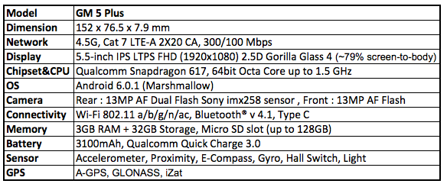
Please visit www.generalmobile.com for details.
Contacts for press communication:
Sevket KARADAYI
Marketing&Business Development Director
sevket.karadayi@generalmobile.com
+90 (555) 255-4179

Berkay KILIC
Marketing Manager
berkay.kilic@generalmobile.com
+90 (533) 232-3866

